 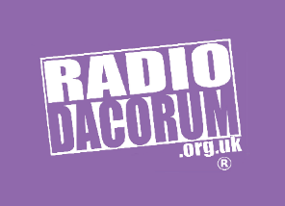

**Community Action Dacorum**

Radio Dacorum Development manager – 37 hrs/week (a minimum of 30 hours will be considered). This is for a 2 Year Fixed Term Contract. Closing date Thursday 10th October 2024.

Salary £26,502 - £33,122 FTE

**BACKGROUND**:

The Radio Dacorum Development Manager role is to focus on growing listener numbers, broadening the schedule content, increasing income and to position Radio Dacorum as an essential part of local (and potentially broader) community life, reducing isolation of residents and improving wellbeing. Please note this is not a broadcasting role.

**JOB RESPONSIBILITIES**:



**PERSON SPECIFICATION**:



*Note: This position description is not definitive and is designed to give an overall view of the job and not to specify in detail all the tasks and duties of the post.*

For an informal discussion about the role please contact Alex Care on 01442 617638. For an application pack, please e‑mail [alex@communityactiondacorum.org.uk](mailto:alex@communityactiondacorum.org.uk%20) or telephone 01442 617638.